

JOB DESCRIPTION & PERSON SPECIFICATION

SERVICE AREA: | Adult, Children & Family Services | POSITION NO:
SECTION: | Children & Family Services | GRADE: 6
JOB TITLE: | Family Practitioner | DATE PREPARED: 24 October 2013
EVALUATION DATE: | 25 October 2013 | JE NUMBER: NC3250
DIGNITY AT WORK: To show, at all times, a personal commitment to Looked After Children and treating all customers and colleagues in a fair and respectful way, which gives positive regard to people’s differences and individuality (for example, gender, gender identity, nationality or ethnic origin, disability, religion or belief, sexual orientation, age). Assists in ensuring equal access to services and employment opportunities for everyone and promotes the Council’s Equal Opportunities in Employment Policy.

PURPOSE:
To support the delivery of high quality social work activities with the Hull Children’s Social Care Practice Model through the provision of direct support work to children, young people and families. Works within the Access & Assessment, Locality, Disability or Looked After Children Service across a range of specialisms eg. fostering, adoption, children with disabilities, children’s residential, child protection, children in need, with the aim of achieving the best possible outcomes for children and young people in need and their families.

To actively work as part of the whole service system, supporting colleagues in the day to day running of the service area (across either localities or city wide services).

PRINCIPAL ACCOUNTABILITIES:
Please note decision making must be included within the Principal Accountabilities
1. | To promote and safeguard the welfare of children and young people and to support families.
2. | Contributes to the overarching strategy in Hull Children’s Social Care Services – to ensure that the pod/team actively plans for safety, permanency and stability for children and young people regardless of the setting in which they live and to actively support children to live at home safely.
3. | Works in partnership with colleagues, parents and carers, ensuring that child-centred, systemic practice is the principal standard and framework for all work undertaken with children, young people and families. Provides specialist family work including supporting parenting assessments, life-story work, wishes and feelings work, strengthening families and family nurturing.
4. | Engages in critical reflection and constructive challenge within the course of working with colleagues, other agencies and with children, young people and families.
5. | Undertakes specific pieces of direct work with children, young people and families both individually and co-working with colleagues as directed by the Consultant Social Worker. This includes supporting the assessment and case/care planning work with other professionals.
6. | Actively engages in weekly meetings to support the provision of focused and purposeful social work being undertaken with all cases. Supports the case decision-making process and engages in a range of case management processes eg. case conferencing, reviewing and contributing to reports.
7. | Works with colleagues in the pod/team to ensure that children, young people and families are regularly and actively communicated with.
8. | Engages in regular meetings with children, young people and families and other practitioners and professionals as directed by the Consultant Social Worker.
9. | Works with colleagues in the pod/team to ensure that case recording is up to date and that required information is available for a variety of purposes eg. core group and multi-agency meetings.
10. | Actively engages in the professional development framework for Hull Children’s Social Care Services (including attendance at practice development groups) and continuous learning relevant to the role.
14. | The Health and Safety at Work etc. Act 1974 and associated legislation places responsibilities for health and safety on Hull City Council, as your employer and you as an employee of the council. In addition to the Councils overall duties, the post holder has personal responsibility for their own health & safety and that of other employees; additional and more specific responsibilities are identified in the Council’s Corporate H&S policy.
GENERAL: The above principal accountabilities are not exhaustive and may vary without changing the character of the job or level of responsibility. The post holder must be flexible to ensure the operational needs of the Council are met. This includes the undertaking of duties of a similar nature and responsibility as and when required, throughout the various work places in the Council.

DIMENSIONS:
All sections should be completed – if there aren’t any state ‘none’
1. Responsibility for Staff: No direct responsibility for staff other than contributing and promoting the work of the pod/team and the service area.

2. Responsibility for Customers/Clients: Responsible for contributing to the welfare and protection of service users within the context of the Hull Children’s Social Care Practice Model. Liaises directly with children, young people and families within a systemic framework as directed by the Consultant Social Worker. Communicates sensitive and sometimes contentious information to other professionals as directed by the Consultant Social Worker.

3. Responsibility for Budgets: Supports and promotes the most effective and efficient deployment of resources within the context of the Hull Children’s Social Care Practice Model.

4. Responsibility for Physical Resources: Contributes to the maintenance of a healthy working environment and ensures that equipment used by the pod/team/service is maintained and/or maintenance needs reported.

WORKING RELATIONSHIPS:
All sections should be completed – if there aren’t any state ‘none’
1. Within Service Area/Section: High quality, systemic working relationships within the pod/team (including Consultant Social Worker, Social Workers, Clinician and Pod Co-ordinator). High quality, systemic working relationships with ‘buddy’ pod, colleagues within the immediate service area and Group Manager as required. High quality, systemic working relationships with colleagues providing ‘early help’ support services eg. Children’s Centres.

2. With Any Other Council Areas: High quality working relationships with colleagues across other directorates where an element of community/social support is pertinent in relation to case work.

3. With External Bodies to the Council: High quality working relationships with Voluntary and Community Sector agencies, Health, Education and Police within the locality/across the city and with other local authorities and social care departments.

ORGANISATION CHART:
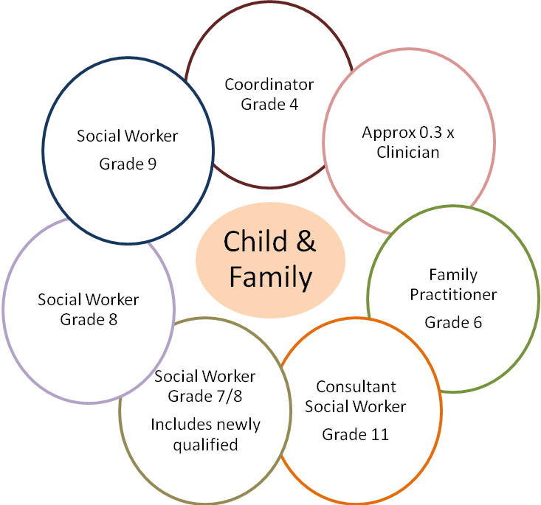
Assistant City Manager (up to 3 group managers depending on service area)
Group Manager (up to 10 pods or teams depending on service area)

 | Tick relevant level for each category
 | Not applicable | Low | Moderate | High | Very High | Intense | Supporting Information  (if applicable)
PHYSICAL DEMANDS:  Physical Effort and/or Strain – (tiredness, aches and pains over and above that normally incurred in a day to day office environment). |  |  |  |  |  | N/A | Occasional exposure to physical demands over and above that normally incurred in a day to day office environment eg. packing belongings/ cleaning.
WORKING CONDITIONS:  Working Conditions – (exposure to objectionable, uncomfortable or noxious conditions over and above that normally incurred in a day to day office environment). |  |  |  |  |  | N/A | Occasional exposure to noxious conditions eg. poor environmental home conditions and substance misuse paraphernalia.
EMOTIONAL DEMANDS:  Exposure to objectionable situations over and above that normally incurred in a day to day office environment. |  |  |  |  |  |  | Family Practitioners to work in high conflict/socially challenging situations alongside experienced colleagues.

PERSON SPECIFICATION |  |  | Tick relevant column |  | List code/s*
The information listed as essential (the column that is shaded) is used as part of the job evaluation process. The requirements identified as desirable are used for recruitment purposes only.  *Codes: AF = Application Form, I = Interview, CQ = Certificate of Qualification, R = References (should only be used for posts requiring DBS’s), T = Test/Assessment, P = Presentation |  |  | Essential | Desirable | How identified
1. | Qualifications:
1. | Educated to GCSE standard English and Maths or Literacy & Numeracy Award equivalent. |  |  |  | CQ
1. | Level 4 Qualification in a relevant subject focused on working with children, young people and families eg. Level 4 Award in Work with Parents – Intense Support for Families with Multiple & Complex Needs (within 24 months of taking up role) |  |  |  | CQ
 | Full driving licence. |  |  |  | CQ
2. | Relevant Experience:
2. | Experience of working directly with service users. |  |  |  | AF/I/R/T/P
2. | Experience of working within the legal framework for Children’s Social Care. |  |  |  | AF/I/R/T/P
2. | Experience of working directly with service users deploying a research based methodology eg. systemic practice. |  |  |  | AF/I/R/T/P
3. | Skills (including thinking challenge/mental demands):
3. | Motivation to work with children, young people and families. |  |  |  | AF/I/R/T/P
3. | Ability to form and maintain appropriate relationships and personal boundaries with children, young people and families. |  |  |  | AF/I/R/T/P
3. | Practical direct working skills with children, young people and families to advise, support, persuade and engage them in meeting their goals and potential. |  |  |  | AF/I/R/T/P
3. | Able to think reflectively and creatively in relation to direct work with children, young people and families. |  |  |  | AF/I/R/T/P
3. | Able to work autonomously and as part of a wider group within the service area and prioritise work efficiently. |  |  |  | AF/I/R/T/P
4. | Knowledge:
4. | A knowledge and commitment to safeguarding and promoting the welfare of children and young people. |  |  |  | AF/I/R/T/P
4. | Sound knowledge of the Children Act and Child Protection Legislation. |  |  |  | AF/I/R/T/P
4. | A sound knowledge of principles and procedures relating to the support and monitoring mechanisms for children and young people eg. care planning, case conferencing and Looked After Children Reviews. |  |  |  | AF/I/R/T/P
4. | Basic knowledge of systemic practice and its application in the Children’s Social Care arena. |  |  |  | AF/I/R/T/P
5. | Interpersonal/Communication Skills:  Verbal Skills
5. | Ability to establish professional, effective working relationships with a range of partners/colleagues and children, young people and families. |  |  |  | AF/I/R/T/P
5. | Good verbal communication skills with a high degree of customer focus and able to maintain a professional approach at all times. |  |  |  | AF/I/R/T/P
5. | Able to build excellent rapport with children, young people and families and colleagues within the pod/team and service area. |  |  |  | AF/I/R/T/P
5. | Written Skills
5. | Ability to write accurately and concisely with a high level of attention to detail. |  |  |  | AF/I/R/T/P
5. | Ability to write sensitively and clearly for children, young people and families where necessary. |  |  |  | AF/I/R/T/P
5. | Ability to communicate effectively and professionally through written work. |  |  |  | AF/I/R/T/P
6. | Other:
6. | None
The requirements listed below are not considered during the job evaluation process, but are essential requirements for the role that will be assessed during the recruitment process.
7. |  | Competencies:
 |  | The competencies listed below are all essential requirements for working at Hull City Council in any post; however, those that have been ticked as essential have been identified as key competencies for this role and will be measured as part of the selection process. They are not required to be addressed in the candidate’s application form.
 |  | Leading forward |  | N/A | I/R/T/P
 |  | Improving services |  | N/A | I/R/T/P
 |  | Analysis and decision making |  | N/A | I/R/T/P
 |  | Making things happen |  | N/A | I/R/T/P
 |  | Communicating with impact |  | N/A | I/R/T/P
 |  | Collaboration |  | N/A | I/R/T/P
 |  | Developing self and others |  | N/A | I/R/T/P
 |  | A copy of the Competency Framework can be accessed via the Council’s website – www.hullcc.gov.uk/jobs
8. |  | Additional Requirements:
 |  | Able to work flexibly to meet the needs of children and families. |  |  | AF/I
 |  | Able to transport/escort service users (including children). |  |  | AF/I
9. |  | Disclosure of Criminal Record:
 |  | The successful candidate’s appointment will be subject to the Council obtaining a satisfactory Enhanced & Children’s Barring List Disclosure from the Disclosure & Barring Service (if ticked as an essential requirement). |  | N/A | DBS Disclosure
 |  | If the postholder requires a DBS disclosure the candidate is required to declare full details of everything on their criminal record. |  | N/A | AF(after short listing)
 |  | If the postholder does not require a DBS disclosure the candidate is required to declare unspent convictions only. |  | N/A | AF(after short listing)

